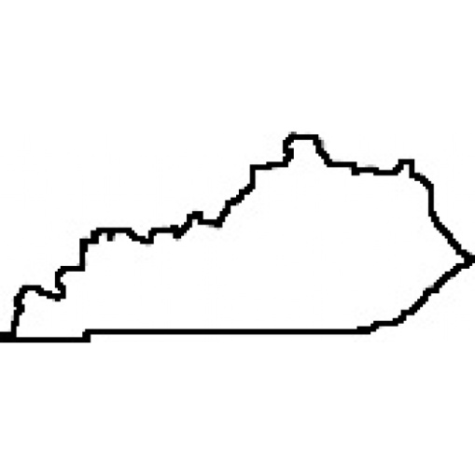
Volume 72, Edition 1 Spring Newsletter Year 2014
Kentucky
FCCLA
Kentucky assotiation of the Family, career, and Community Leaders of America

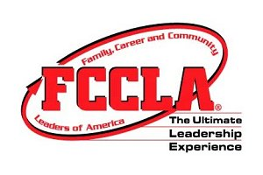

State Meeting Keynote Speaker
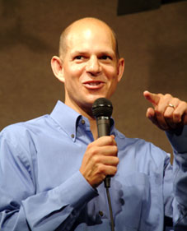
Known as one of America’s best youth leadership development speakers, Ted Wiese works with thousands of students every year to teach and enhance their leadership skills. Ted is in the business of making students believe they can make a difference - and he teaches them how to do it! From starting his career with Junior Achievement to establishing Wiese Training and Development, LLC, Ted’s dynamic and engaging programs have gained him a strong reputation for delivering results.
For years, the students at Ted’s presentations have laughed while they learned. His fun-filled keynotes contain contagious laughter coupled with a strong message, while his activity-oriented workshops develop student leadership skills in an energetic, highly interactive, humorous and effective manner. With wit, wisdom, real-life stories and a whole lot of fun, his programs leave students with information and skills to take back to school, ideas to put into action, and something good to talk about in the days and months ahead.
Whether you bring him to your school or conference for a keynote, workshop or concurrent session, he will work with you to make your event a memorable success. For more information go to www.heartedtalk.com

Kentucky FCCLA 69th Annual State Meeting

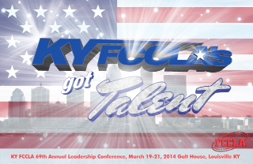
Kentucky FCCLA are you ready? The Ultimate Leadership Experience is coming to you from the Galt House in Louisville live with “FCCLA’s Got Talent!” March 19th through the 21st. Plans have been made to ensure that this year’s meeting is a success and we want all of you to be a part of the experience.

This year the keynote speaker for the opening session on Wednesday evening, March 19th, is Ted Wiese. He is a well-known powerful youth speaker nationwide. Each year he works with thousands of students in an effort to enhance their leadership skills. He is in the business of making students believe that they can make a difference and teaches them skills they can use to do so. Since he began his career with Junior Achievement and continued by developing Wiese Training and Development, he has been known to bring about results through his programs. He will bring us the same positive presentation at the State Leadership Conference.

The State Executive Council has some changes to this year’s conference. Following the opening session members will be dismissed to attend regional meetings that will be led by each of the region’s officers. Also, at the conference you can look forward to fewer and larger sized concurrent sessions to attend. Arrangements are currently being made to confirm the attendance of some very special guests that will lead those and a Community Service Showcase will be set up during concurrent session rotations for students to share examples of community service projects being completed across the state. This year several exhibitors will be set up during the concurrent sessions as well for those in attendance to purchase items.

STAR Events competition has been moved back to one day this year and because of that we have several activities members can participate in to keep busy. On Wednesday afternoon members are free to tour the attractions of Louisville and at 3:00 p.m. a Zumba class will be held. Throughout the conference be sure to keep an eye out for “Flat Stanley” State Officers around the hotel. A Twitter and Instagram account will be set up for members to tag KY FCCLA when taking pictures with the cutouts. After the banquet on Thursday evening a Cast Party will be held for everyone. A dance instructor will be present to teach everyone line dances.

The 69th Annual State Leadership Conference is quickly approaching and we look forward to seeing each and every one of you there! Kentucky FCCLA are you ready? Make sure to register soon and bring your talent to this year’s “KY FCCLA’s Got Talent!
Kentucky Exceeded Expectations in Charlotte, NC!

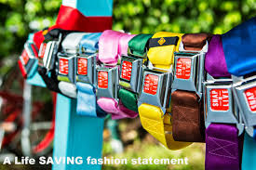
November 22nd through 24th, 2013, representatives from Kentucky attended the National Cluster Meeting held in Charlotte, North Carolina. The theme of this meeting was “Exceeding Expectations”, which is exactly what KY FCCLA did!
During this meeting, students learned about an organization called, Snap-2-Live, an initiative in support of the United Nations’ “Decade of Action for Road Safety” campaign. Snap-2-Live belts are fashion accessories that look like actual vintage automobile seat belts and buckles, and act as highly visible reminders of what we can do every day to save lives on the road. Snap-2-Live pledges 70 percent of profits to road safety initiatives, creation of new roads and safe communities for under- served families in developing countries.

Students competed in many different competitive events.
Winners include:
Culinary Food Art-
Tied for 2nd Place Grayson County High, Madison Willis
Culinary Knife Skills-
2nd Place Grayson County High, Jo Trator
FCCLA Creed Speaking & Interpretation-
1st Place Crittenden County, Audrey Smith
2nd Place Sharp Middle School, Michael Smith
Impromptu Speaking-
1st Place Crittenden County, Amber Wright
3rd Place Crittenden County, Hannah Hardin
Knowledge Bowl finalists-
DuPont Manual students Captain: Callie Kidwell, Caroline Folz, Anthony Springate, Paige Thompson, and Emily Wilbar. DuPont Manual is to compete at the July National Leadership Conference in San Antonio, TX

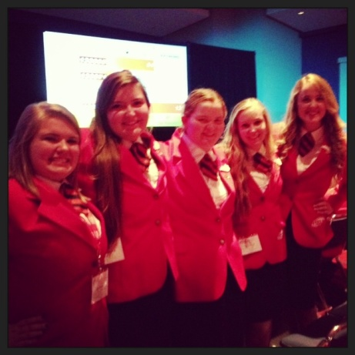
Kentucky FCCLA truly exceeded expectations, developing leadership skills, competing in competitive events, attending workshops, and listening to inspirational speakers. If you have not attended a National Cluster Meeting yet, I highly encourage you to attend one of the 2014 National Cluster Meetings in Little Rock, Arkansas, Salt Lake City, Utah, or New Jersey!
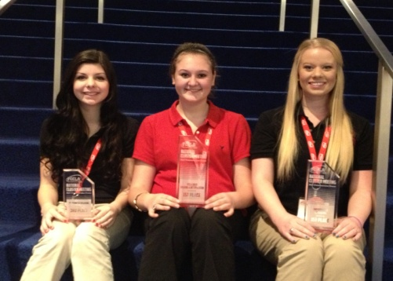
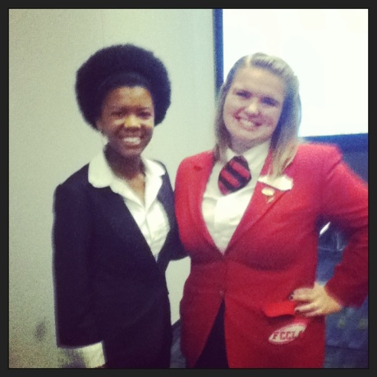
Crittenden County High School Winners
KY State Officers attending Closing Session
Previous KY State Officer of Finance, Rave n Byers and Current State Officer of Finance attending a workshop
KENTUCKY FCCLA
Community Service Update

2014

SPRING NEWSLETTER

State-Wide Community Service Project:

I hope that as the 2013-2014 school year comes to a close you haven't forgotten to contribute to the State-Wide Community Service Project! Kentucky this past year has been able to assist military personnel, active or retired, and their families. Please continue to assist our service members and their families this year and beyond. Currently only 10 schools have submitted their activities for the year. It is not too late for you to become involved. Please send pictures, statistics, activities, and more to the Kentucky State Vice President of Community Service Megan Hughes at megansoccer2410@gmail.com. If you would like to become involved with local activities or if you have any questions you can contact your Chapter advisor, Regional advisor, or me, Megan Hughes.
Thank you for your continued support
and efforts to promote the
State-Wide Community Service Project!
-Megan Hughes
2013-2014 State Vice President of Community Service

TOTALS:
COOKIES: 400+
CARDS: 1,000+
DONATIONS$741.20
BACKPACKS: 100+
EVENTS:
20+

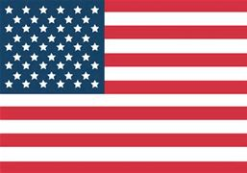

SPECIAL THANKS TO PARTICIPATING SCHOOLS
• Ballard Memorial High
• Boyle County High School
• Bourbon County High School
• Burgin Independent High School
• Clay County High School
• Fleming County High School
• Greenwood High School
• Oldham County High School
• Ryle County High School
• South Warren Co. High School

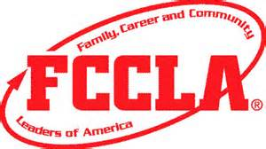

Student Leadership Day

Student Leadership Day took place February 10-11th in Frankfort, Kentucky. There, FCCLA State Officers were joined by other State Officers from different branches of Career and Technical Student-Led Organizations. That include, FFA, FBLA, HOSA, Skills USA, DECA, FEA, and TSA from all across the state of Kentucky. They all attended a workshop about the legislative process Monday night. On Tuesday, the officers attended the Education Committee meeting where the FFA State President, gave his testimony for the committee. After that, Officers met with their district Representatives and Senators to thank them of their support of Career and Technical Education and Career and Technical Student Organizations. At eleven a rally was held at the Capitol rotunda, hosted by the FBLA State President and included our FCCLA State President, Michaela Mineer. The rally had two guest speakers who are products of Career and Technical Education themselves and spoke on even though they are not in the area of CTE they learned many lessons that they use every day because of it.
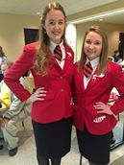
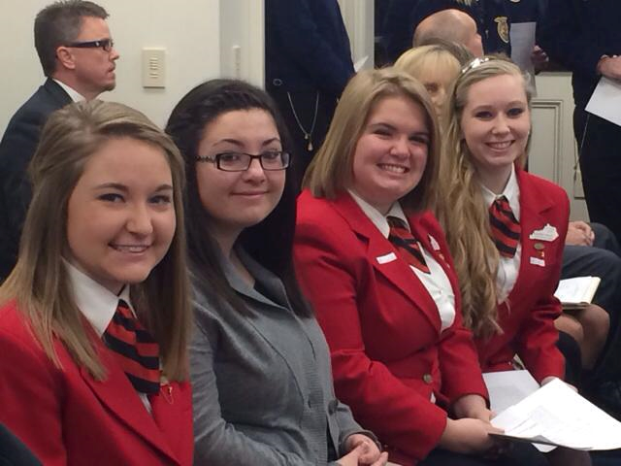
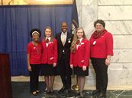

“Officer Spotlight”
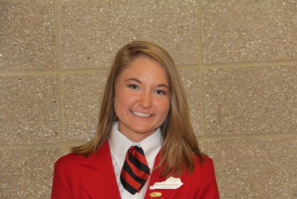
Name: Michaela Mineer
Office: President
Region: Region 9
Other activities outside of FCCLA: Along with FCCLA, I am on the Girl’s Golf Team and am also a member of FBLA, FCA, and the Fleming County High School Journalism Staff. My time outside of school is spent giving piano lessons to children and spending time with my youth group, family, and friends.
The reason I became a state officer: I became a state officer to serve the Kentucky Association and to help lead it to success. I wanted to be there to serve members and be a part of something so life changing.
Favorite Leadership Quote: “If your actions inspire others to dream more, learn more, and become more, you are a leader.”

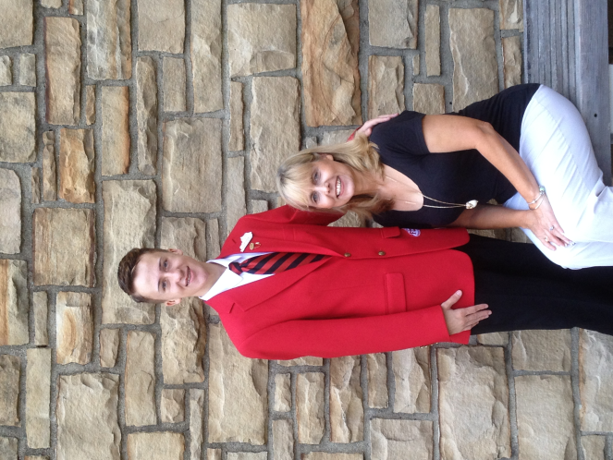
Name:Eldar Gorak
Office:Vice President of Individual Programs
Region: Region 4
Other activities outside of FCCLA: Activities I am involved in other than FCCLA are; FBLA, Student Advisory Council, Dragon Council for Warren central High School, Bosnian American Club, Chemistry club, Biology Club, also a member of the Warren Central High School tennis team, I volunteer at many places such as the local humane society, and a riding stables. I also work two part time jobs.
I became a state officer because I saw the love and passion of the past officers. I saw the fact that there was not a single stranger at a Kentucky FCCLA meeting; you spoke to everyone as if they were your best friend.
Favorite Leadership Quote: “if you care enough for a result, you will most certainly attain it.” - William James

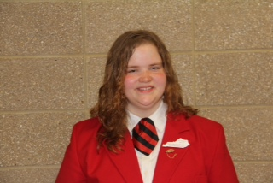
Name: Brooklee Boots
Office: Vice President of Membership
Region: Region 7
Other activities outside of FCCLA: Varsity Golf, National Spanish Honor Society

state officer: To serve the incredible organization of FCCLA
Favorite Leadership quote: “Never believe that a few caring people can't change the world. For, indeed, that's all who ever have.” –Margaret Mead

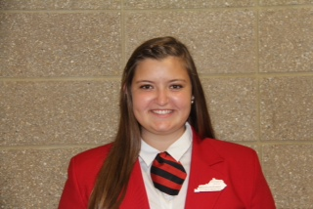
Name: Brooklyn Evans
Office: VP of Public Relations
Region: Region 5
Other Activities outside of FCCLA: SADD Club, Youth Service Council, Senior Advisory Council, Student Council, St. James Youth group, 2nd grade Religious Education teacher aid
The reason you became a state officer: I became a state officer because KY FCCLA has given me the leadership opportunity of a lifetime. I wanted to but the skills FCCLA has given me to use by serving this great organization.
Favorite Leadership Quote: A leader is one who knows the way, goes the way, and shows the way. —John Maxwell

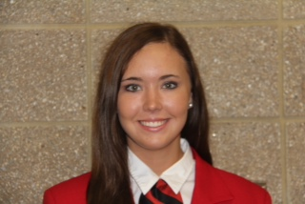
Name: Katelyn Clark
Office: VP of STAR Events
Region: Region 4
Other activities outside of FCCLA: HOSA, BETA, and Pep Club. I’m also actively involved in my church youth group, and I volunteer at the outreach for the needy ministries in my community.
The reason you became a state officer: I chose to run for a state office because I wanted to dedicate myself to an organization that focuses on building strong family relationships, preparing for the future, and helping others in the community. I strongly encourage others to run for a state office because it helps develop leadership skills while having fun!
Favorite Leadership quote: “A true leader has the confidence to make tough decisions and the compassion to listen to others. He does not set out to be a leader, be becomes one by the equality of his of his actions and the integrity of his intent” –Douglas Mac

2013-2014 KY State Executive Council

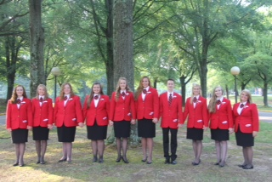

King’s Size Hearts for King’s Cause
By: Taylor Stewart (1st Vice President)

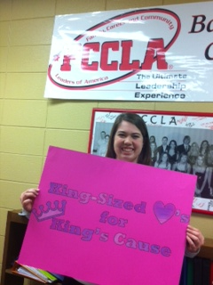
It’s no secret that Family, Career and Community Leaders of America members and advisers become close. Between long hours dedicated to competitive events, meetings, projects, and more, everyone in the FCCLA community becomes a family. When a FCCLA family member goes through a difficult time, everyone wants to do what they can to give service. A year-long community service project in Region 15, “King’s Size Hearts for King’s Cause” directly benefits Ms. Elise King and her one year old son. Ms. King is a Family and Consumer Sciences teacher and FCCLA adviser for Western Hills High School in Frankfort, Kentucky. In January 2013, Ms. King’s husband was diagnosed with cancer. He passed the following April. Ms. King, Region 15, and Kentucky FCCLA were heartbroken. She and her students were very active in their region. They often had members that held regional offices, served on regional committees, and competed in STAR Events. Because of Ms. King’s dedication to Region 15, the regional officer team wanted to show their appreciation of her service. Over the course of the school year at all regional events, members and advisers have sold King Size candy bars for one dollar. All proceeds are directly donated to her son’s education fund. “FCCLA is more than just an organization. We are a family,” says Region 15 President Julia Little (Boyle County High School). “She is a dear friend to every adviser and a joy to be around. Ms. King and her students play a significant role in the success of our region.” The total amount of money collected for Ms. King and her son’s education fund is to be calculated at the end of the school year.

Curious George Fun Day

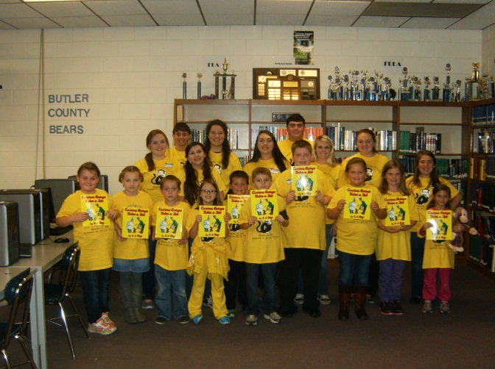
Curious George Fun Day was a one day program held at Butler County High School on November 23, 2013. Second and third graders were invited to attend and experience a day of fun and reading. The children received a t-shirt and the book Curious George Takes a Job. Throughout the day children had the opportunity to paint, decorate cookies, make skits, watch a Curious George film and have free play time. The children were also served breakfast and lunch. FCCLA members Allison Kurfiss, Bailey Hunt and Rachel Johnson coordinated the event. The members said that they wanted to have this day because there are so many activities for children surrounding sports and other things but few that emphasize reading. They said they felt it was important to show the children that reading can be fun and can be applied to everyday life.

IT CAN WAIT CAMPAIGN

Washington County High School Sophomores Jenny Begley and Claire Miller recently attended the Teen Distracted Driving Summit in Washington D.C. The two were one of only 12 pairs of students that applied for and received an al1-expenses-paid trip to the conference. One of the most eye-opening revelations was that it takes approximately six seconds to read a text message, and within those six seconds, you've travelled the length of six football fields. Having learned facts like these Jenny and Claire decided to take their knowledge back to their hometown. In April, before Prom, Washington County FCCLA will be doing a mock crash scene trial on distracted driving and showing students the dangers involved with it. Traci Blanford, WC's FCCLA adviser that accompanied the two on the trip, said that all of the students will have a chance to follow a student through four different scenes: at a party, at a head-on collision, at a hospital and then, finally, at a funeral. Once each student has been through each scene, a guest speaker will wrap up the demonstration at a school-wide assembly. Jenny Begley hopes it will have an emotional impact on the students and will help decrease distracted driving in their community. The mock crash is one of many ways they plan to decrease distracted driving in their community. They have registered WCHS on the website celebratemydrive.com to raise more awareness at their school. The two have also talked to the U.S Representative for Springfield’s district, Brett Gurthrie, to see if he could help change and implement the policies. There are a variety of apps dedicated
to stopping distracted driving, but the one that stood out the most to Begley doesn't allow any texts to come through to a driver. “This is a really serious case in our society, and we need to find ways to diminish it." –Jenny Begley

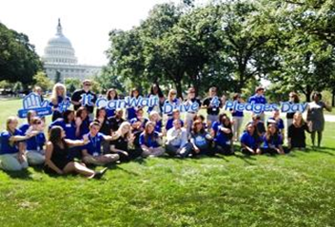
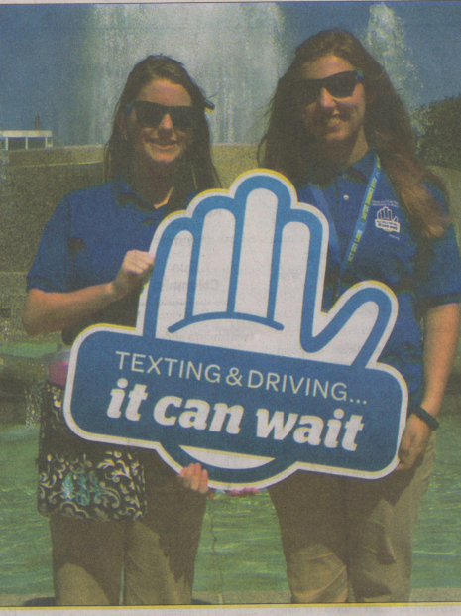

Jenny Begley and Claire Miller at the Teen Distracted Driving Summit

Teen Distracted Driving Summit in Washington D.C.

