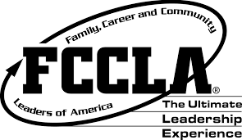
Kentucky FCCLA
Family, Career, and Community Leaders of America
Volume 73, Edition 1 Fall Newsletter 2014
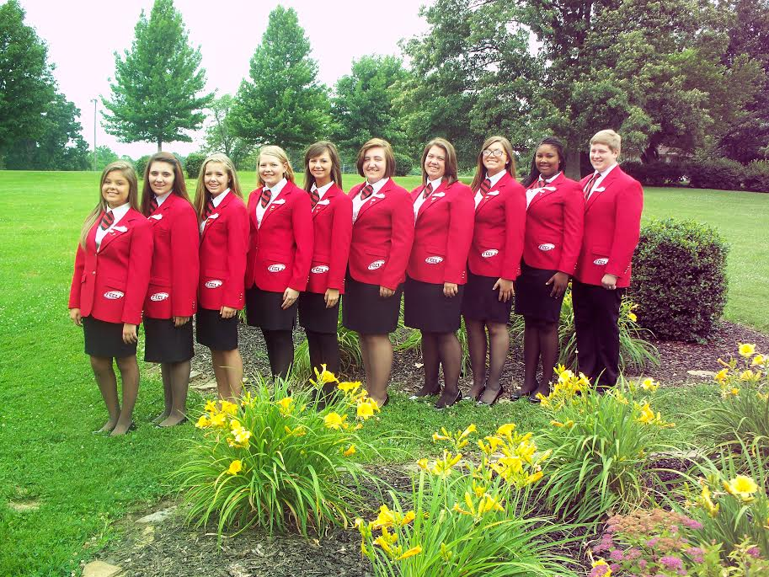
The State Executive Council (SEC) is honored to serve as your 2014-2015 officers. We would personally like to thank all members and advisers for your constant support and work in helping us to better Kentucky FCCLA. We are excited for what the year has in store for us for we have improved tremendously as individuals with hopes to serve you all as members. Continue the good work and as you do share it with us by positing pictures of your success in activities and projects at #KYFCCLA.
Your Family,
The 2014-2015 Kentucky State Executive Council

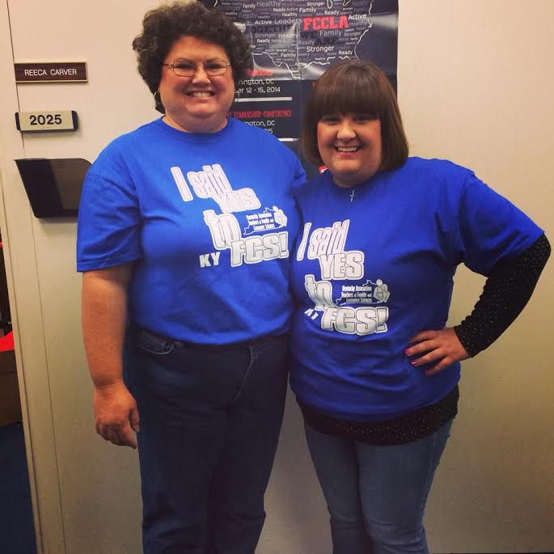
A message from the KY State Adviser:
Kentucky FCCLA Members, you are a part of an organization that is 70 years strong in 2015. FCCLA has developed members to be successful as a family member, wage earner and community members that are career ready with its rich traditions, innovative ideas for the future since we are the only organization that focuses on the family.
At this time of year during the holiday season, I hope you will take advantage of being with your family members and learning the history of your family. Find out stories or activities that they may have participated in during their school years. Be sure and take the pledge and prepare a meal for your family to help FCCLA @ the table get the 70,000 meals to build stronger families one meal at a time!
Be a part of the activities for the school year whether it is a community service project to assist the Pennies for Patients, Share our Strength No Kid Hunger, Lead2Feed, complete a degree/ Power of One project, work on a national program like Families First or compete in a STAR Event. Together with FCCLA we are successful! Mark your calendar to attend the 2014-15 KY FCCLA State Leadership conference at the Galt House in Louisville, KY March 30- April 1, 2015 so you can be a part of the “Kentucky FCCLA on Exhibit, 70th Ed.”
This year we are excited to add to our KY FCCLA family Miss Kayla Godbey as she is the new Family and Consumer Sciences State Supervisor and KY FCCLA State Board Chair. Ms. Godbey was a family and consumer sciences teacher at Boyle County High School for 6 years and two years at Garrard County High School. Kayla was also a former state officer and intern. She is a graduate from Boyle County High School and the University of Kentucky. She does bleed blue and FCCLA Red. Welcome to the state department and the Office of Career and Technical Education Miss Kayla Godbey.
Reeca Carver

2014 National Leadership Conference Recap
The 2014 National Leadership Conference was help July 6th- 10th in San Antonio, Texas. Roughly 200 members, advisors, alumni, and guests joined as they soared toward new horizons. This year’s theme was unveiled as “Together we are …” Throughout this five day conference your SEC was trained to perform their duties effectively and members shared their ideas on improving the organization with members from the 50 states, Virgin Islands and Puerto Rico. Members also got an exclusive on our newest program “FCCLA at the Table”.

2014-2015 State Goals

Members of the State Executive council voted on the 2014-2015 Kentucky FCCLA goals, which are:
- Maintain or increase membership by 7 members in honor of our 70th year of our
establishment.
- Implement at least 3 diverse activities within the Program of Work. (i.e., Farm Day, Unite To Read, etc.)
- Participate in the statewide community service project, Pennies for Patients.
- Increase number of honor roll participants with scholarship donations and news article submissions.
- Increase state degrees or Power of One applications by 7 members per chapter.
- Increase participation in all competitive events by 7%.
- Support Senate Bill 20 by implementing an anti – bullying campaign.

A message for the President
Kentucky FCCLA,
Princess Diana once said “Family is the most important thing in the world.” We know this statement is so true. As Family, Career, and Community Leaders of America, we put family as our central focus. This year, Kentucky FCCLA is doing a great job of promoting family. I encourage your chapter and region to be a strong family unit. Support each other and work toward goals that will make a difference.
The Kentucky FCCLA State Executive Council has great plans in store but we have also done some amazing things so far. Kentucky FCCLA Leadership Camp: The Power is Yours was held June 9-11, 2014 where regional officers were trained by the State Executive Council to perform their duties efficiently! Next, the SEC and other Kentucky FCCLA members headed down to San Antonio, Texas for the 2014 National Leadership Conference. There we networked with other members across the nation, attended sessions, and attended the installation of the 2014-2015 National Executive Council. As the summer came to an end, the start of FCCLA recruitment started. Next, was National Cluster Meeting! The SEC hoped you had a great time at either location you went to! Even though this meeting is short, it was full of great workshops, networking sessions, and site seeing!
The SEC and I hope to see everyone at the 70th Annual State Leadership Conference, March 30- April 1st. The SEC has some great things in store for you! Also when posting anything about your chapter, region, or state use the hash tag #KYFCCLA to keep your SEC in the know! Good luck with the rest of this year!
Julia Little
Kentucky National STAR Event Winners
We are proud to announce our national STAR Event winners. We appreciate your hard work and dedication. Congratulations!
Kaleigh Woods
Madison Flora
Michaela Royse
Taylor Lawson
Whitney Nucklos
Reagan Cole
Sierra Morrow
Allison Dicks
Tyler Jackson
Ashton Chaney
Evan Allen
Grace Isaacs
Sidney Bayless
Abigail Spencer
Kaleigh Jones
Olivia O’Hearn
Ashley Batey
Sierra Anderson
Lauren Ferguson
Savannah Caldwell
Myrna Hill
Noah Roberts
Tate Dowdy
Morgan Applegate
Olivia Leet
Skylar Logan
Claire Miller
Jenny Begley
Shelby White
Kaitlyn Myers
Katie Travis
Kristen Perryman
Carey Hulette
Cara Spalding
Randi Gray
Ashley Croft
Audrey Smith
Kayla Ford
Madasen Cosby
Tania Thompson
Annabelle Cooper
Aspen Arnold
Becca Daugherty
Brandon Jones

Emily Wallace
Erica Daugherty
Haley Ford
Brooklyn Dunn
Marissa Matthews
Meara Devlin
Noelle Burchett
Samantha Orange
Emma Lawson
Lakynn Hodges
Victoria Hamilton
Bryce Hendrickson
Tanner Pitakis
Will Porter
Megan Huber
Sydney Dawson
Brianna Adams
Libby Carter
Avery Hatfield
Janee Beaman
Olivia Chill
Samantha Smallwood
Gabrielle Emmons
Heather Marshall
Alyssa Bayless
Becky Laber
Alexis Thompson
Grace Barnett
Paige Parks
Aletha Thomas
Breanna Hubbard
Haley Burns
Hanna Hammonds
Holley Blackburn
Gena Brumley
Halie Melson
Jamie Hester
Courtney Maynard
Jonathan Yaunk
Anne Redmon
Anne Fallis
Emily Cox
Austin Tackett
Kelsey Dryden

Kathryn Justus
Kitrina Justus
Rachel Justus
Haley Edge
Ivy Donaldson
Hayley Leach
Cheyenne Milby
Caroline Folz
Brady Vaughn
Briana Cid
Stasia Schum
Kaci McCelland
Alexxi Ballinger
Carli Linville
Karlee Nolder
Megan Robinson
Bailey Woford
Hannah Edlen
Genna Kieper
Kortney Carver
Sylvia Stahl
Belinda Cheng
Ivy Neal
Kyrsten Hill

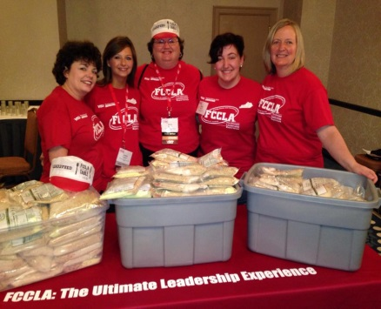
Amanda Bowman
Blaike Selby
Demarion Johnson
Hannah Phillips
Alex Smith
Ashley White
Jacob Cantrell
Madison Stamper
Addison Hendley
Jalonda Wells
Meteah Black
Anna Holman
Jennifer Hamilton
Mirelle Taylor
Sara McOmber

Jordan Wheatley
Madison White
Makenzie Dean
Brooke Lytle
Jordan Fidler
MacKenzie Fryman
Evan Mitchell
Henry Cho
Jenna Perkins
Adam Cornette
McKayla Jude
Jackie Pi
Brandon Blanford
Anna Crider
Haley Robinson

Robbie Rowlett
Jamie Pack
Stephen Adams
Mary Mansfield
Irlyn Herren
Luccia Yamada
Braydon Dungan
Megan Perkins
Bailey Lowery
Lauren Baker
Olivia Wright
Christen Reid
Carrie Coleman
Grace Harris
Gaubrie Humphress

Capital Leadership

The following KY delegates that attended the Capitol Leadership from left to right: Sarah Raikes, Washington Co, Hannah Edelen State VP Peer Education, Reeca Carver State Adviser, Kendall Gott State VP STAR Events, Angela Gott Metcalfe Co Adviser. Along with other Capital Leadership attendees partook in the Lead2 Feed community service project where over 10,000 food bags were created to be distributed out in the community of Washington DC. While at the conference members met with legislators and their staff to advocate about FCCLA and family and consumer sciences topics such as student body and healthy families. “It was an incredible experience not only to learn about how to advocate, but to actually go out and apply what we had learned by meeting legislative staff, along with Senator Rand Paul. I'm beyond blessed to have gained personal insight, advocacy training, and ultimately, lasting friendships.” -Hannah

Paige Crawford
Carey Elliot
Madison Bonzo
Tori Lawson
Danielle Elias
Heather Luce
Nyeisha Eaves
Emily Jacobson
Jamie Pennell
Jordan Licata
Julie Perkins
MacKenzie Purvis

Cassandra Redd
Savannah Byrd
Kaitlin Gore
Megan Stubbs
Mollie Leach
Faith Workman
Madison Ivey
Katana Whitaker
Maicee Harless
Maghan Harless
Raygan Kilby
Brianna Blackburn

This year our state goal is to increase Power of One participants, along with State Degree participants by 7 members per chapter for the 70th year of KY FCCLA. My chapter has been inviting members to stay after school on Wednesdays to work on their Power of Ones, State Degrees, and Star Events projects. I encourage all chapters to get a head start on each of these projects. All applications for Power of Ones are due to the state adviser Ms. Carver at 2025 CPT 500 Mero, Frankfort, KY by February 1st. All applications for the State Degree are due to your regional Vice President of Individual Programs adviser by February 1st. If you have any questions feel free to contact me at rhea.hammer@stu.monroe.kyschools.us.
Rhea Ann L. Hammer
KY FCCLA Vice President of Individual Programs

Hello KY FCCLA,
I know each and every one of you is excited to have FCCLA started again. Our plan for the community service project this year is Pennies for Patients. For this year I am encouraging everyone to get involved and come up with one great campaign idea for raising money for the "Pennies for Patients" foundation. We have sent more details to each chapter. I look forward to seeing everybody at state meeting and everybody participating in this year’s community service project. Please send me pictures of your chapter during the "Pennies for Patients" project. Have a great school year and a great year in FCCLA!
Dalton Adamson
State FCCLA Vice President of Community Service
Chapter Spotlight
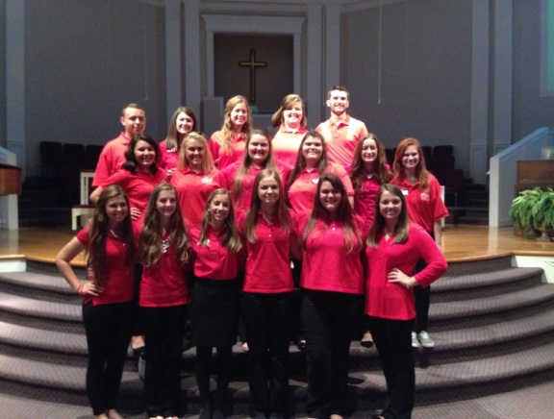
Hopkinsville High School
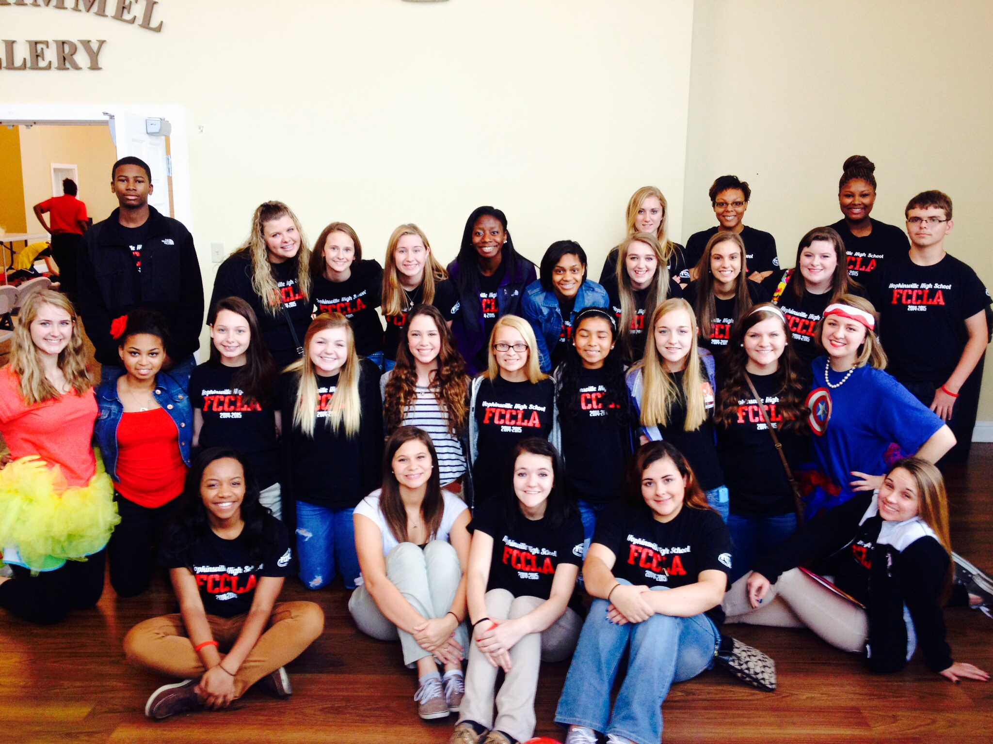
Hopkinsville High school is proud to recognize its growing club and active members. This year the club has doubled its sized and has made a bigger impacts in their community than ever before. They look forward to the rest of the year. Together they are MAKING A DIFFERENCE.
Jessamine County

On Friday, September 27, 2014, Jessamine County took 17 members, including 11 officers, of FCCLA (Family, Career and Community Leaders of America) to the Fall Regional Training Workshop. Our FCCLA chapter is excited to start off the new year with our new officers!

Pulaski County High School
On September 25, members of the Pulaski County High School FCCLA chapter underwent a journey of growth. They attended the 2014-2015 Fall Regional Meeting with the intentions of training Chapter Officers in their specific duties.
The theme of this meeting was “Together We Are FCCLA Strong.” All of the attending Chapter Officers were given materials and ideas to help their chapter grow. This was a very fun and effective learning experience for all of those involved. Everyone in the Pulaski County chapter gained a tremendous wealth of knowledge regarding their positions as officers and devoted members.

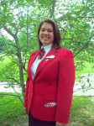
Officer Spotlight
Name: Julia Little
Office: President
The reason you became a state officer: I wanted to make an impact for the better. In our society today family is becoming less of a priority and students are falling into trouble more and more. Family is one of my first priorities and I wanted to be a leader in Kentucky FCCLA to help their impact on Kentucky families. I also wanted to inspire others to become leaders. I know that the state officers from my freshman year inspired me to get involved and now here I am! I am so excited to serve and help student leaders on their journey to make a difference.
Favorite Quote would be from the Bible in Matthew 10:43, "Whoever among you wants to be a leader must be a servant." I believe this to be so true! Leaders must be on the last of the list and everyone else is first. You can count on your state executive council to serve you to the best of our abilities. We strive to put Kentucky first!
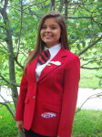
Something interesting: I absolutely love kids and want to hang out with kids any chance I get! I am more of a big kid myself! ☺
Name: Makayla Lindsey
Office: Vice President
The reason I became a state officer: I became a state officer because I wanted to make a difference in the Kentucky Association of The Family, Career, and Community Leaders of America. I also wanted to see the behind-the-scenes work of the State Conference.
Favorite Quote: "For I know the plans I have for you, said The Lord, plans to prosper you and not to harm you, plan to give you hope and a future." -Jeremiah 29:11
Something interesting: I have every movie ticket I've ever seen! (:
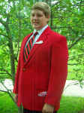
Name: Dalton Adamson
Office: VP of Community Service
The reason I became a state officer: I wanted to help improve our organization and every since my first state meeting I always wanted to be on that stage wearing a red blazer.
Favorite Quote: Life was given to us a billion years ago. Now you know what to do with it. – Lucy. This is my favorite quote because it inspires people to go out and do what you want with your life. Life was given years ago and you shouldn't wait to do something with it.
Something interesting: I want to major in the culinary or medical field.
Name: Gabby Ingram
Office: VP of Finance
The reason I became a state officer: I went to my first state meeting and saw all of the state officers on stage and asked my advisor if we had anyone from my school as a state officer and she said no; I wanted to be the first.
Favorite Quote: “Today you are you. That is truer than true. There is no one alive who is youer than you” – Dr. Seuss. This is my favorite quote because it reminds me that even when I feel like I can’t do anything right, and that everyone else is better than me, that I am myself and no one can change that.
Name: Rhea Ann Hammer
Office: VP of Individual Programs
The reason I became a state officer: Coming into this organization as a freshman, I had heard a lot of good things about it. Once I went to my first state meeting, I saw the officers on stage and I automatically knew that I wanted to be a state officer, and I wanted to have a red blazer! I told my advisor and she said that she had been waiting for the right person to tell her that and I was the one. I got a regional office my sophomore year. Once that term was up I knew I was ready. By setting my mind to it, I achieved my goal of becoming a state officer. I recommend becoming a state officer to anyone! This experience has brought me out of my comfort zone, I can now talk in front of 1,000 people without that nervous feeling being my stomach!
Favorite Quote: "Life isn't about waiting for a storm to pass, it’s about learning to dance in the rain." I love this quote because it describes me. I don't wait for things to happen, I make them happen. This quote is saying when it’s a rainy day, don't just set inside looking out; go outside and look in. Play and have fun on the rainy days!
Something interesting: I have one brother. My small town only has 4 red lights. I have had perfect attendance from Kindergarten- 10th Grade; I'm working toward the other two years.

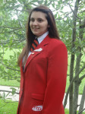
Name: Marsha Allen
Office: VP of Membership
The reason I became a state officer : During first state meeting as a freshman, our chapter had the State VP of Membership, I was inspired by her leadership and courage. I know now I really had no idea what FCCLA was even about. Each year of high school, I found myself more and more involved in FCCLA through competition, activities and leadership positions. Ultimately, I ran because I wanted to be a part of the state executive council to help other students like me grow as leaders and become successful.
My favorite quote: I find strength in Philippians 4:13: “I can do all things through Christ who strengthens me."
Something interesting: On summer vacation in 2011, I was stung by jellyfish in eight different places.
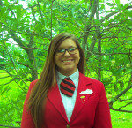

Name: Kaitlyn Myers
Office: VP of Parliamentary Law.
Favorite Quote: "You may not know where you are going, but so long as you spread your wings the winds will carry you." - C. JoyBell C.
Something Interesting: My future goals include going to college to pursue a Master Degree in Business Marketing. I spend my free time with my family and friends.
Name: Hannah Maria Edelen Office: VP of Peer Education
The reason I became a state officer: The reason I decided to run for a state office is simply because of one, lovely human being: Sarah Raikes. She is the advisor of the Washington Chapter, and my personal advisor. Not only has she been a teacher, advisor, and mom, but she has been a friend.
Favorite quote: “Be the Change You Wish to see in the World.” – Gandhi. That’s exactly what I want to do. I long to create a non-profit organization, become a spokesperson, and so many other things. I aspire and the reason why I do is because I long to make an impact on this world whether it be little or big.
Something Interesting: This past year at the 2014 HOBY, I was inspired to go home and make a difference in my community. Two weeks after coming home, I drafted my plans for creating a non-profit organization called “Wedu4u”- an organization designed to provide educational supplies to schools in KY that are in need.
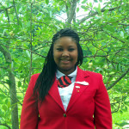
Name: Mikayla Swindler
Office: VP of Public Relations
The reason I became a state officer: After being a member for a year and seeing what a huge difference a group of people could make in a community, I wanted to do more. I wanted to do something that would change someone because changing one person is enough to change the world. So I ran for a state office hoping to change the world starting in my town, now in the state I love in.
Favorite Quote: “Be yourself; everyone else is taken.” – Oscar Wilde. I love this quote because it makes it okay for everyone to be different. Be yourself because there will never be another you. Tear down your idols.
Something Interesting: My long term goal in life is to own a clinic to provide health care services to the underprivileged.
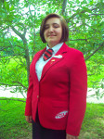
Name: Kendall Gott
The reason I became a state officer: I can became a state officer to give a voice to all members of FCCLA and to welcome everyone no matter who they are.
Favorite Quote: “If you judge a fish on its ability to climb a tree it will like its whole life believing that it is stupid.” – Albert Einstein
Something interesting: After graduating college I want to be a YouTuber.
Your 2014-2015 State Executive Council
